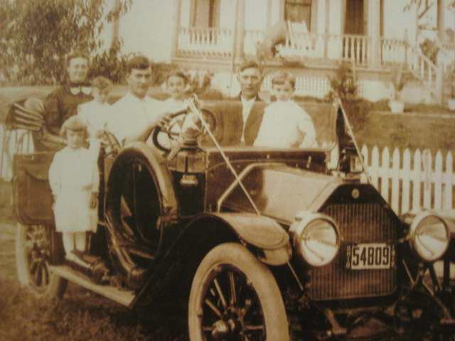

The John and Margaret Kern List Family: Picture taken in 1912

l-r - Margaret holding Noah Emerson, Wilma Catherine on the running board, Philip Adam, Emma Marie, John Adam, John Luther (father of Ronald, David, Dorothy Jo, Mark and Brenda

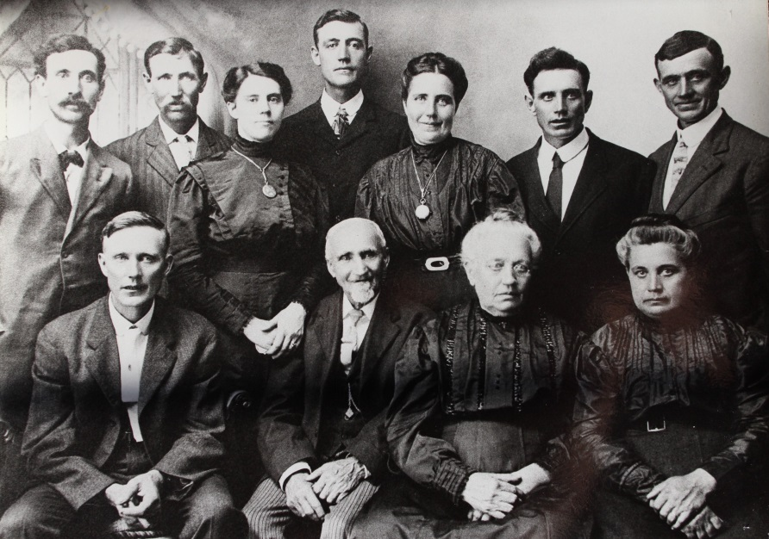

(l-r) First Row: John A. List (Luther’s father), John P. List (immigrant),

Sophia List (John P. List’s wife), Henrietta “Etta” List Hulse

Back Row: Adam List, Charles List, Mary List Kline, George List,

Anna List Follrod, James List, Will List - – about 1913 (est)